Lesson Plan Title

Subject:  Related Subjects: | Grade Level(s):  Length of Lesson: | Type: Inquiry / Design / Project  Keywords:

Lesson Overview
Use this section to describe at a high level what the lesson is. Should be no more than 3-4 lines.

Lesson Focus
What is the central question or phenomenon being investigated? What problem are they trying to solve?

Lesson Objective(s) | State the objective of the lesson. Ideally one to two lines of what the lesson plan attempts to achieve.  This project will introduce food chains. Students will: Learn more about the movement of energy through food chains, Understand the role of producers, consumers, and decomposers in the ecosystem.

Lesson Timing

5 minutes | Introduce the Lesson
30 minutes | ...

Materials | - Markers, Paper
Instructor Prep | - Step 1
Related Resources | - List related lessons/ppts etc available from USC or outside, trusted orgs

Lesson Plan

Introduction
Every movement, every thought, every action is powered by converting energy
from a usable form into a less usable form. This means, however, that we need a
source of usable energy. For people, the energy we use comes in the form of food. This
is true of all animals that eat things. Since they eat food to get their energy, we call them
consumers. Plants, algae, and various bacteria and archaea do not eat to get energy.
Thus, we call them consumers. Lastly, while fungi and some bacteria do eat things to
get energy, they break down dead matter and return nutrients to the soil, so we call
them decomposers. They do not need to digest any material.

Procedure
1. After the lesson on food chains
and the roles in the food chain, the
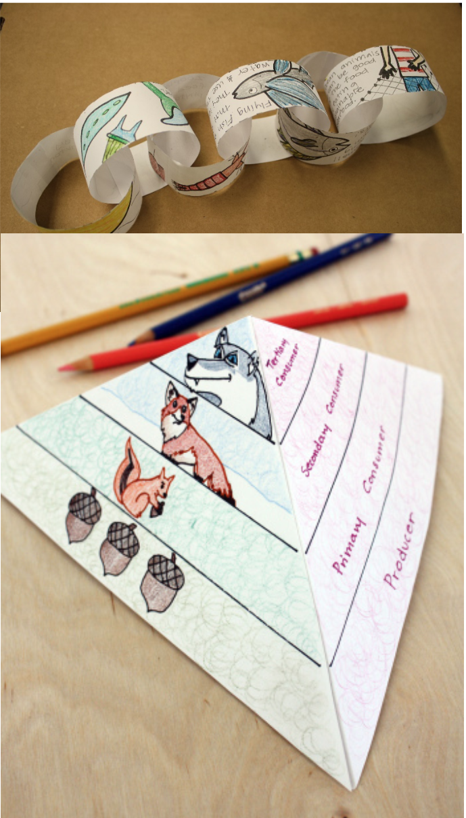
students will begin by playing a
game:
a. There are four different organisms: grass, rabbits, snakes, and hawks.
Everybody starts as grass (encourage body movement to help indicate
which organism they are)
b. Grass players must play rock paper scissors with each other to advance to
rabbit. They must beat two other grass players in a row to advance. If you
lose two in a row, you go down a level.
c. Then rabbits must play to be able to reach snake, etc.
d. The game ends when somebody becomes the hawk

2. Then the students will build their own food chains. I will encourage them to
present the food chains in a creative way, because simply writing animal names
and drawing arrows can get boring.
a. Examples for inspiration: A 3 dimensional pyramid with a food pyramid
drawn on it. Strips of paper cut and linked together to make a literal chain.
Organisms drawn on each link of the paper chain.

Wrap-up
End the lesson with some final discussions about what students designed/discovered. Connect their activity back to the focus question/problem, real world examples, and STEM careers.

Also include notes about any special cleanup considerations

Lesson Background for Teachers

Suggested Real-World STEM Connections
- List possible related Role Models in STEM (with details and links to more reading). Give suggestions for examples of scientists/engineers who are from underrepresented groups in STEM in related careers.
- List related real-world engineering problems and examples

Lesson Variations and Options
Include descriptions of alternative methods or ways to present things.

Explanation
Describe the background concepts and explanations behind the lesson. This can be more in depth than a teacher/instructor would actually share with students.

Key Concepts and Vocabulary
- Word 1: Grade Appropriate Definition
- Word 2: Grade Appropriate Definition

Safety Notes
- Safety instruction

